Experiment No. 2
Signal Operations and Transformations
  - To perform amplitude scaling and time scaling of continuous-time and discrete-time signals and analyze their effects on signal characteristics.
S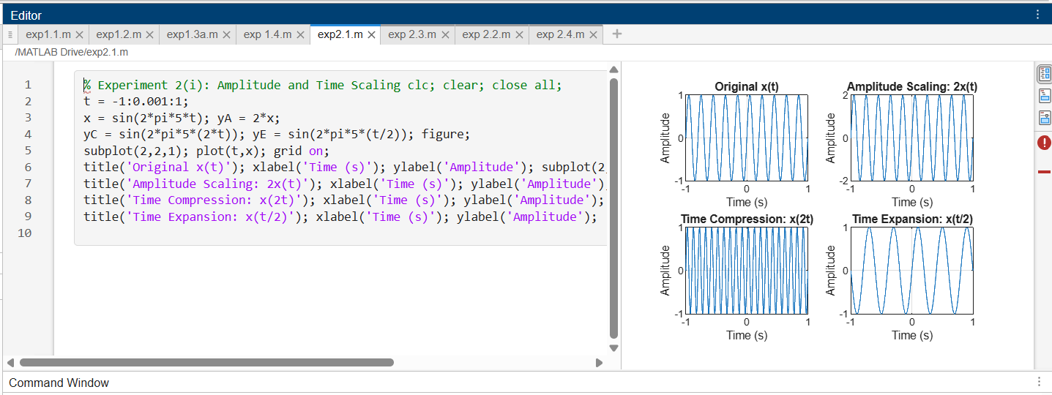
  - To perform addition and multiplication of two discrete-time sequences and analyze the resulting signal characteristics.
